

LABCOL-2293

Building Webex Teams bots using business logic templates

WISP Proctors:

Vladimir Savostin

Sergey Sazhin

Alexey Sazhin

Introduction and Learning Objectives

Upon completion of this lab, you will get practical experience working with interface of Webex Teams bots, while hiding complexity and concentrating on business logic.

Doing this lab, you will build and run a Webex Teams bot for one of the business process types:

- Sample bot (***‘whoami’*** and ***‘echo’*** use cases)

- TAC Self Service (information about defect)

During the lab you will:

* Learn bot’s capabilities in Webex Teams
* Use python webexteams SDK API calls to register the bot with Webex Teams
* Integrate bots with database
* Make bot handle photo and text
* Get familiar with business logic templates to use them in the future

During FIFA WorldCup 2018, guests were supported by the bots used as crucial part of social responsibility campaign.

In this lab, you will be presented with the platform, tools and components to build the bots in Webex Teams. You will also be shown how to use business logic templates to run different automation workloads on top of platform integration. You will also get references regarding platform design decisions and how to solve the most usual problems. You will also learn how to run automation of business processes using bots interface.

Disclaimer

This training document is to familiarize with writing Webex Teams bots for social campaigns. Although the lab design and configuration examples could be used as a reference, it’s not a real design, thus not all recommended features are used, or enabled optimally. The code’s principles in this lab was tested in social campaign during FIFA WorldCup 2018 so it mighn’t work optimal and efficient in all environments. For the design related questions please contact your representative at Cisco, or a Cisco partner.

Table of contents

Introduction and Learning Objectives 2

Disclaimer 2

Table of contents 3

Scenario 4

Get started 6

Anyconnect VPN establishment 6

High-level Lab’s Topology 8

Bot’s integration with external entities 9

Bot’s integration with Webex Teams clients 9

Flask 9

Ngrok 10

Notes: 10

Option #1: Become Webex Teams user 11

**Step 1: Add yourself to the Webex Teams bot** 11

**Step 2: Get information about defects from Webex Teams bot** 12

**Steps 3 See how the bots are created:** 12

Option #2: Become Webex Teams bot’s developer (intermediate) 19

**2.1 Write sample bot** 19

**2.2** **Run interview/quiz** 22

Option #3: Become Webex Teams bot’s developer (advanced) 24

**3.1 Write sample bot** 24

**3.2** **Run internal Company’s event (Secret Santa)** 24

**3.3** **Run external marketing campaign** 24

Related Sessions at Ciscolive 26

Summary 26

Appendix A. List of Acronyms 27

Scenario

Disclaimer:

This is a work of fiction. Names, characters, businesses, places, events, locales, and incidents are either the products of the author’s imagination or used in a fictitious manner. Any resemblance to actual persons, living or dead, or actual events is purely coincidental. But it’s based on a true story.

**Imagine the following:**

1. There are many routine information that you need to collect from the devices. Your department is understaffed and even despite of you’ve being working only with collaboration products for many years (congratulations, you are Collaboration SME!), your manager asks you to prepare different reports by yourself. You know, your network is comprised of many different technologies:
2. Routing & Switching
3. Security
4. Wi-Fi
5. Collaboration

From one of the Cisco trainings, you remember there is ability in Cisco Webex Teams bots for the integration with Cisco Support APIs to get information about defects, EoX and inventory information from the equipment.

**In the current lab, you have three options (see Figure 1):**

1. Option #1 – Learn how interact with bots in Webex Teams and get needed information (tech level – basic, if you are not feeling yourself ready to become a programmer).
2. Option #2 – Write the Webex Teams bot, integrate it with Cisco API and give it to your support desk so they can find defects information quickly by themselves. Write the Webex Teams bot to perform quiz for technical interviews (tech level - intermediate).
3. Option #3 – Write advanced Webex Teams bot, using advanced integration capabilities. (tech level - advanced)

**Figure 1 – High-Level overview of the lab tasks**



Get started

Bot’s access token along with Anyconnect credentials to be collected from a Webex Teams bot ([**PinaColada@sparkbot.io**](mailto:PinaColada@sparkbot.io)):

1. Login to Webex Teams using your (existing) account credentials in Webex Teams web application.

If you don’t have existing Webex Teams account, use credentails from your lab access ticket.

1. In a Webex Teams, find the following bot among a list of users:

**PinaColada@sparkbot.io**

1. Start a room space with the bot and type the following command to get your credentials:

**/accesslab <hash>[1]**

For each Bot access token, PinaColada bot sends username of the respective bot (for testing purposes, when Python script is with bot's code is running)

Anyconnect VPN establishment

Please connect to the lab with **Cisco AnyConnect** :

1. Start **Cisco AnyConnect** on your laptop.
2. Copy the **Host** URL from the **AnyConnect Credentials** (sent by **PinaColada**) and then paste it in the **URL Connection box** in the **AnyConnect** login window.
3. Click **Connect**.  
   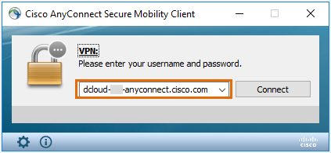
4. Copy a User ID and the password from the **AnyConnect Credentials** and then paste each into the **Cisco AnyConnect** login window.
5. Click **OK**.
6. Click **Accept** on the window confirming your connection.
7. When connected to your AnyConnect VPN session, the AnyConnect VPN icon is displayed in the system tray.
8. To view connection details or to disconnect, click the AnyConnect VPN icon and then choose **Disconnect**.

RDP connection

1. Copy RDP connection details from [**PinaColada@sparkbot.io**](mailto:PinaColada@sparkbot.io)
2. Establish RDP connection, using Microsoft RDP client

High-level Lab’s Topology



**Figure 2 ̶** **High-level Lab’s Topology**

Above is the lab’s toplogy. The central part of lab is Cisco Webex Teams bot, which is to be written on Python.

Below is high-level information about topology of the lab, please, read it carefully, before start doing the lab.

Bots are similar to regular Webex Teams users. They can participate in 1-to-1 and group spaces and users can message them directly or add them to a group space. A special badge is added to a bot's avatar in the Webex Teams clients so users know they're interacting with a bot instead of a human.

A bot can only access messages sent to it directly. In group spaces, bots must be [@mentioned](https://collaborationhelp.cisco.com/article/en-us/p5k20o) to access the message. In 1-to-1 spaces, a bot has access to all messages from the user.

Bots do not, however, perform actions within Webex Teams on behalf of a Webex Teams user. If you're creating an application that needs to participate in Webex Teams and perform actions with a user's account, check out [Integrations](https://developer.webex.com/docs/integrations).

Bot’s integration with external entities

Depending on the path selected and chosen task, it will communicate with the following external entities:

1. Data Sources:

* PostgreSQL
* MongoDB
* Text files in JSON format

1. Gmail (via SMTP)

Bot’s integration with Webex Teams clients

In every task of the lab, a bot would be communicating with a Webex Teams client (in the course of this lab, web-based client of Webex Teams is used).

A bot can’t communicate directly with Webex Teams clients, but does it via Webex Teams Cloud.

Communication is established in the following way:

1. In order to deliver messages, bot sends HTTP POST to a client – directly through Webex Teams Cloud.
2. In order to get messages from a client – bot is programmed to listen to Webhook from Webex Teams Cloud. Each time Webex Teams Cloud detect message from a client – it notifies a bot using Webhook (using HTTP POST).

JSON is used as format of sending data between Python bot and Webex Teams Cloud.

Flask

In order to be able to receive Webhooks from Webex Teams Cloud, a bot must be integrated with Web Server. In a course of the lab, [Flask](http://flask.pocoo.org/), an easy and powerfool framework would be used to run a web server on Python.

Ngrok

Since a bot is running on a server which isn’t reachable from the Internet, [Ngrok software](https://ngrok.com/) is used to host Public URLs using which bot’s web server could be reachable (for building webhook integration).

Notes:

* In the lab, client and server, while a logically separate entities in a drawing above, are physically hosted on the same machine.
* All script for bots are tested on Python 3.7.2 but should also work on another Python 3 releases.
* Cisco Webex Teams client exists in agent and agentless (web-based) form-factors. Throughout this lab web-based client would be used.

Option #1: Become Webex Teams user

Technical level of this task: **basic**

**Option #1 Steps (Use TAC Self Service bot to find issue):**

* Add yourself to the existing Webex Teams bot.
* Get answers for the questions to fix all issues in your network (the bot, which is written in “Quiz” task in Option #2 is used here).
* Create and run sample bot (shows information about your Webex Teams account and echoes back received messages)
  1. **Add yourself to the Webex Teams bot**

Cisco Webex Teams client exists in agent and agentless (web-based) form-factors. Throughout this lab web-based client would be used.

1. Use the following link to open a web-based Webex Teams client:

[https://teams.webex.com/](https://teams.webex.com/spaces)

1. Enter email address[2], press Next
2. Enter password1 and press **Sign In** button.
3. On the left corner in a Search tab, input name of Service Webex Teams Bot:

**CLEUR_LABCOL2293_SERVICE@webex.bot (see Figure 3)**

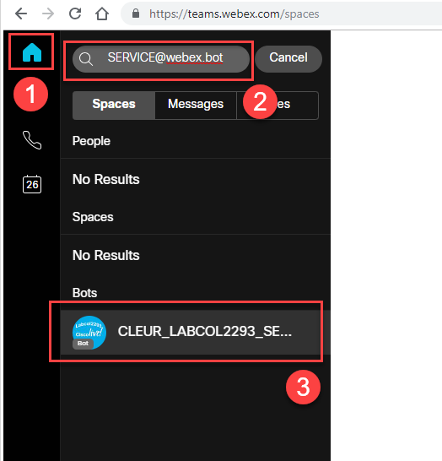

**Figure 3 ̶ Find a service bot (CLEUR_LABCOL2293_SERVICE@webex.bot)**

**1.2 Get information about defects from Webex Teams bot**

1. Webex Teams space would be created, so that you can chat with a bot.
2. Start putting bug ids into a chat box in a space with a bot (see **Figure 4**).

**/bug <bug_id>**

You can user the following bug ids to test bot’s functionality:

/bug CSCdr72939

/bug CSCvb57414

/bug CSCuz44968

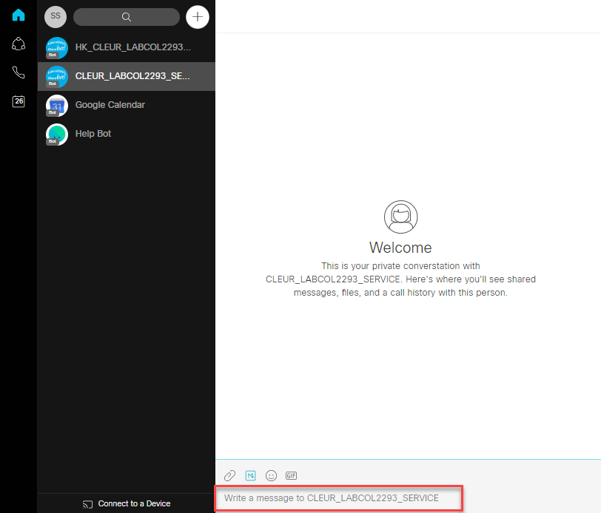

**Figure 4 ̶ Chat with a service bot**

**1.3 See how the bots are created**

Create, start you own bot and interact with it in Webex Teams client.

All script for bots in this lab are written on Python 3[3].

1. Create a bot on Webex Teams.
2. Create a [Webhook](https://developer.webex.com/docs/api/guides/webhooks) (so that a bot could listen to the messages of Webex Clients).
3. Copy code of sample bot from GitHub.
4. Replace Bot's Access Token in a configuration of a bot.
5. Start Ngrok.
6. Start Bot (Python script).
7. Open Webex Teams client and start chatting with a basic bot.

Step 1 Create a bot on Webex Teams

There are two parts to create a bot:

* Create a “user” account on Webex Teams, using Webex for Developers.
* Create a program that provides the brains behind the created account.

1. Login to the following URL to create a new bot:

<https://developer.webex.com/login>

1. On the opened window:

Enter email address[4]

Enter password3 and press **Sign In** button.

1. On the opened window:

Press **Start Building Apps** button

1. On the opened window:

Press **Create New App** button

1. On the opened window:

Press **Create a Bot** button

1. On the opened window fill in all the fields:

**Bot Name, Bot Username:** CLEUR_LABCOL2293_<random number>

**Icon:** Choose one of the default

**Description: CLEUR_LABCOL2293 basic bot test**

1. Press **Add Bot** button
2. On the opened window:

Copy **Bot’s Access Token** (see **Figure 5**), save it in a Windows notepad application.

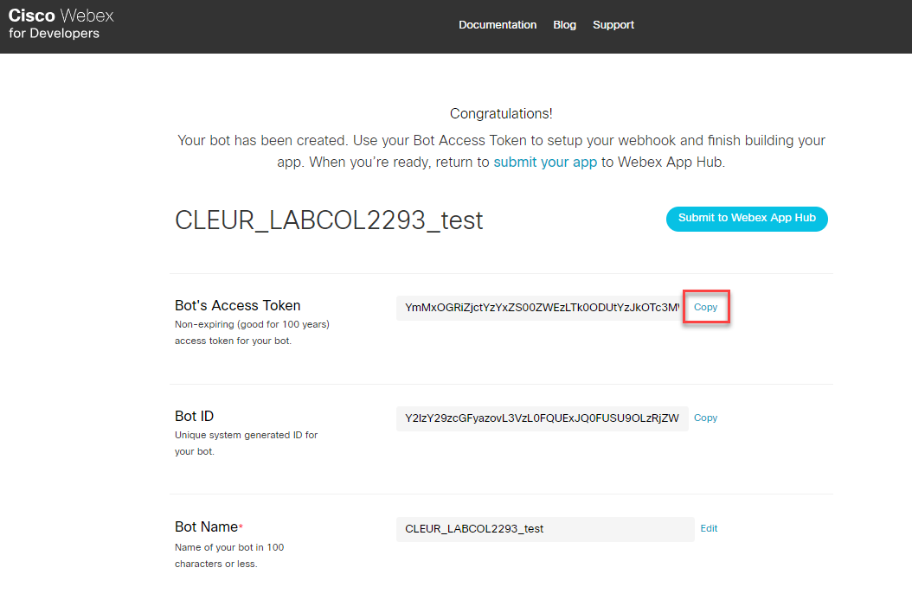

**Figure 5 ̶ Copy bot’s access token**

Step 2 Start Ngrok

Click ngrok-**start.bat** on a Desktop (see **Figure 6**)

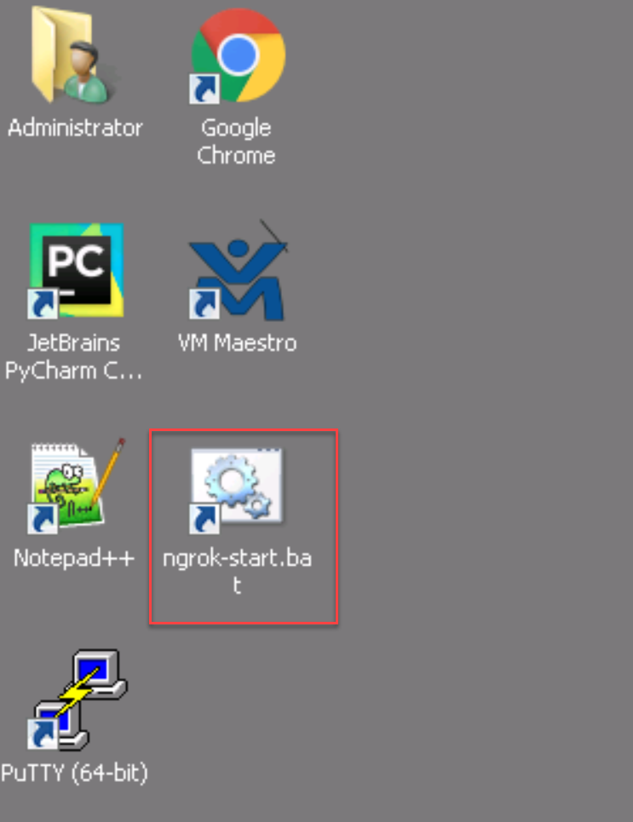

**Figure 6 ̶ Run ngrok-start.bat**

Windows command line would be opened, Ngrok will start to print out the data. Copy http “forwarding” URL (see **Figure 7**). All requests (in case of Webex Teams) coming to this URL would be forwarded to **localhost:5000** (Flask web server would be listening this socket). Copy this URL, which would be required to create a Webhook.

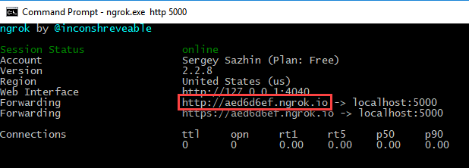

**Figure 7 ̶ Copy http “forwarding” URL**

Step 3 Create a Webhook

In order to make a bot listen to the messages sent by Webex Clients, [Webhooks](https://developer.webex.com/docs/api/guides/webhooks) should be used:

<https://developer.webex.com/docs/api/v1/webhooks/create-a-webhook>

For each bot separate Webhook to be created. In another parts of the lab Webhooks are created automatically by script (based on forwarding URL created by Ngrok).

On the opened window fill in the fields in accordance with stated below, use Figure 8 for the guidance:

1. Authorization – **disable**
2. Bearer: <**Bot’s Access Token, copied in step 8 above>**
3. Name: **CLEUR_LABCOL2293_test_bot**
4. TargetURL: <**“forwarding” URL from the previous step (Ngrok)>**
5. Resource: **messages**
6. Event: **created**

Press **Run** button

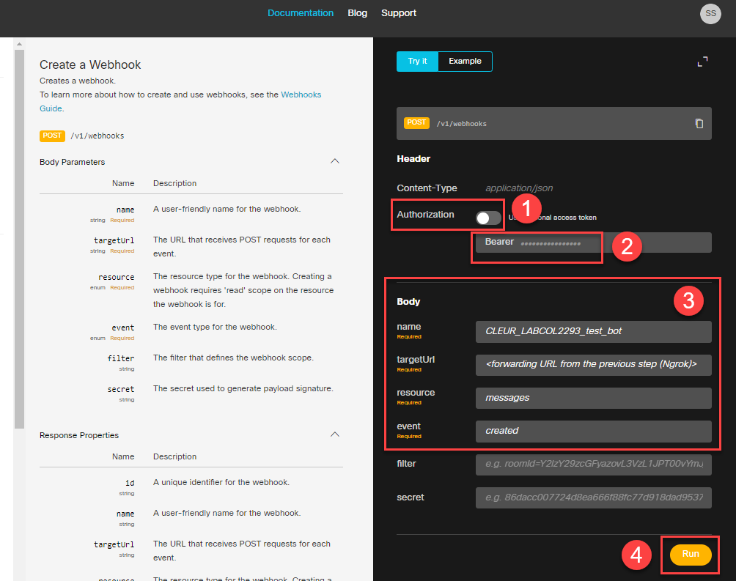

**Figure 8 ̶ Creating a webhook manually**

Step 4 Copy code of sample bot from GitHub

Click “JetBrains PyCharm Community Edition 2018.3.3 x64” on a Desktop to run a PyCharm (IDE for Python)

Open: **VCS -> Checkout from Version Control -> Git**

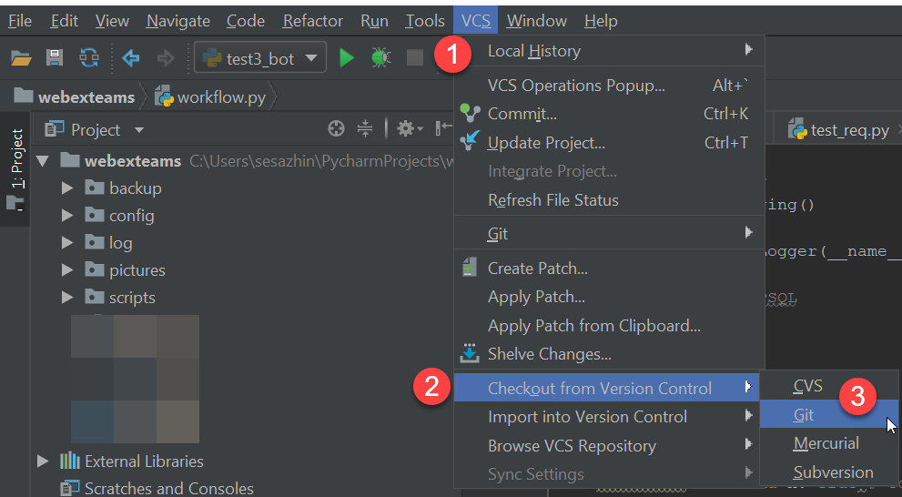

**Figure 9 ̶ Checkout from Git repository**

On the opened Windows use the following data to fill (see Figure 10):

**URL: https://github.com/cleur2293/labcol.git**

Press **Clone** button

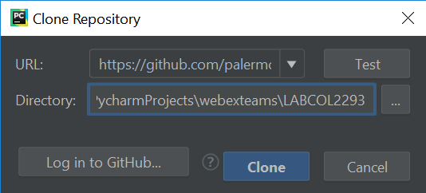

**Figure 10 ̶ Clone Repository Window**

On the opened Window press **Yes** to open the project checked out from GitHub:

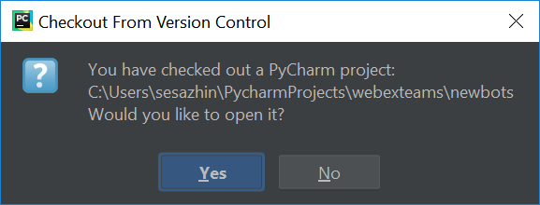

**Figure 11 ̶ Chekout from Version Control Window**

On the opened Window press **This Window** to opened the project in the same window in PyCharm:

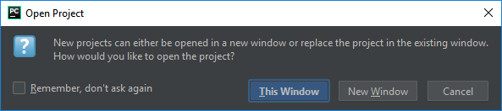

**Figure 12 ̶ Open Project Window**

Step 5 Replace Bot's Access Token in a configuration of a bot

In a PyCharm, open a bot’s configuration file:

**bot_sample -> config -> config.yml**

In config.yml file, after **bot_access_token:** put <**Bot’s Access Token, copied in step 8 above>** (between quotes).

Step 6 Start Bot (Python script)

On the left tab find a Python file with the code for sample bot:

**Bot_sample -> server.py**

Open the file and press Shift + F10 to run the script

Step 7 Open Webex Teams client and start chatting with a basic bot

1. Open a Web Browser with Webex Teams web-client, find the bot with created name: CLEUR_LABCOL2293_<random number>@webex.bot
2. In the created Webex Teams space, start chatting with a bot.

The following actions supported:

* **/whoami** – command that will instruct the bot to show information about your account in Webex Teams
* Input any phrase and bot will echo it back

Option #2: Become Webex Teams bot’s developer (intermediate)

Technical level of this task: **medium**

**Option #2 Steps:**

* 1. Write sample bot.
  2. Create Cisco Support API bot (defect’s information)
  3. Create the Webex Teams bot to perform quiz for technical interviews

You want to get rid of the job, related to the technologies you are not fun of, you want to write the bot to integrate it with Cisco API and give it to your support desk, so they find and fix all technical issues. But for now you think you should get more experience with Webex Teams bots before you start writing the bot for integration with Cisco external API.

To prove your colleagues you can write a Webex Team bot, you decided to show them a “quick win” and write a sample bot.

This will increase your vilibility inside the company, so that your manager and peers now you can use Webex Teams bots to solve current challenges in the innovative way.

* 1. **Write sample bot**

As the first task in your bot’s developer journey,.you will write a sample bot, which supports the following tasks:

* If a user chatting with a bot inputs **/whoami** command, a bot will show an information about user’s account in Webex Teams
* If a users chatting with a bot inputs any phrase, bot echoes it back in the same Webex Teams room

For this task a bot has been pre-created in Webex Teams cloud, you will need Bot access token to make your bot script able to receive and write messages on behalf of the Bot.

A Webex Teams Access Token is how the Webex Teams APIs validate access and identify of the requesting user (bot).

You will need to collect your bot’s access token along with your Anyconnect credentials from a Webex Teams bot. Follow the steps to collect this information:

1. Login to Webex Teams using your (existing) account credentials in Webex Teams web application.

If you don’t have existing Webex Teams account, use credentails from your lab ticket.

1. In a Webex Teams, find the following bot among a list of users:

**PinaColada@sparkbot.io**

1. Start a room space with the bot and type the following command to get your credentials:

**/accesslab <hash>[5]**

1. Save Anyconnect and Bot Access token data for the use during this lab.

You can also follow a chapter **“Create a bot on Webex Teams.”** of this lab guide to check out the process of creating a new Webex Teams bot in Webex Teams cloud.

Now we can use example from webexteamssdk repository as a simple bot. Here is an example of bot who will send some funny facts about cats (It is based on flask, but you may find more examples on Cisco DevNet WebexTeamsSDK GitHub).

When you create a webhook for a particular event, the notification data will be sent as an HTTP POST, in JSON format, to a URL of your choosing, each time it is triggered.

The following solution components to be used as part of this task (see **Figure 13**):

1. Github (PyCharm would be used just to pull Python and configuration files of Webex Teams bots)
2. Flask Web Servrer
3. Ngrok
4. Webex Teams client (web-based)
5. Webex Teams cloud



**Figure 13 ̶ Solution components of sample bot**

To complete this task, the following steps have to be followed:

1. Pull Webex Teams bot’s code from GitHub (see XXX for the details).
2. Prepare and test Python code to run Flask server to get Webhooks from Webex Teams Cloud.
3. Start Ngrok.
4. Prepare and test Python code to create a Webhook, pointing to forwarding URL created by Ngrok
5. Add Webex Teams bot logic to Python code
6. Run Sample Bot

Step 1 Preparation

Pull Webex Teams bot’s code from GitHub

See Chapter “Copy code of sample bot from GitHub.” for the details.

Prepare and test Python code to run Flask server to get Webhooks from Webex Teams Cloud.

Open the following file in the following directory: bot_sample -> lab

**flask.py**

This file will be used to host a Python code to build and run web-server on Flask.

This web-server would be used in the next tasks to receive Webhooks from Webex Teams Cloud.

Below is the code to be used in this task:

1. First we imported the [**Flask**](http://flask.pocoo.org/docs/1.0/api/#flask.Flask) class. An instance of this class (**flask_app**) will be our Web Server Gateway Interface application
2. We then use the [**route()**](http://flask.pocoo.org/docs/1.0/api/#flask.Flask.route) decorator to tell Flask what URL should trigger the function **webex_teams_webhook_events()** each time it gets HTTP GET or POST[6]. This function will only trigger in case /events link is accessed.
3. Ngrok_port would be used as port on which Flask web-server would be listening (static TCP port 5000 to be used in this case):

**from** flask **import** Flask, request  
  
# Initialize the environment

ngrok_port = 5000

# Create the web application instance  
flask_app = Flask(__name__)  
  
@flask_app.route(**'/events'**, methods=[**'GET'**, **'POST'**])

Below is a logic of **webex_teams_webhook_events()** function, that triggers each time it gets HTTP GET requests to the ‘/events’ URI.

This function returns a simple web page with Markdown as a lightweight markup language (used by Cisco Webex Teams). This simple web-page will show “Sample Bot running Flask” message in a web-browser:

def webex_teams_webhook_events():  
 *"""Processes incoming requests to the '/events' URI."""* if request.method == 'GET':  
 return ("""<!DOCTYPE html><html lang="en">  
 <head><meta charset="UTF-8"><title>ServiceBot</title></head>  
 <body>  
 <p><strong>Sample Bot running Flask</strong></p>  
 </body>  
 </html>""")  
  
 return 'OK'

Start Flusk Web server if this is main Python module.

if __name__ == '__main__':  
 *# Start the Flask web server* flask_app.run(host='0.0.0.0', port=ngrok_port)

Copy code from this chapter and paste to **flask.py file**, then run it and try to access using the

Start Ngrok

See Chapter “Start Ngrok.” For the details

Prepare and test Python code to create a Webhook, pointing to forwarding URL created by Ngrok

Open the following file in the following directory: bot_sample -> lab

**webhook-sample.py**

This file will be used to host a Python code to register a new Webhook.

Webhook is created automatically, based on forwarding URL created by Ngrok.

Below is the code to be used in this task:

1. First we imported the [**Flask**](http://flask.pocoo.org/docs/1.0/api/#flask.Flask) class. An instance of this class (**flask_app**) will be our Web Server Gateway Interface application
2. We then use the [**route()**](http://flask.pocoo.org/docs/1.0/api/#flask.Flask.route) decorator to tell Flask what URL should trigger the function **webex_teams_webhook_events()** each time it gets HTTP GET or POST[7]. This function will only trigger in case /events link is accessed.

**from** builtins **import** *  
  
**from** webexteamssdk **import** WebexTeamsAPI  
**import** requests  
**from** urllib.parse **import** urljoin  
  
*# Constants*NGROK_CLIENT_API_BASE_URL = **"http://localhost:4040/api"**WEBHOOK_NAME = **"ngrok_webhook"**WEBHOOK_URL_SUFFIX = **"/events"**WEBHOOK_RESOURCE = **"messages"**WEBHOOK_EVENT = **"created"**bot_access_token = **'SAMPLE'**

In the code above, variable **bot_access_token** should be replaced with Bot's Access Token (to be taken from lab access ticket)

The following functions **are pre-built in a file (webhook-sample.py)**:

1. get_ngrok_public_url() - Connects to an Ngrok management interface via API (http://localhost:4040/api

/tunnels), represents answer in JSON format, providing list of forwarding URLs provided by Ngrok.

1. get_ngrok_port - Connects to an Ngrok management interface via API (http://localhost:4040/api

/tunnels), represents answer in JSON format, providing port which is used by Flask web-server (Ngrok forwards all HTTP requests coming to this port on Flask)

1. delete_webhooks_with_name - Connects to Webex Teams API to check whether there is Webhook with the same name (uses WEBHOOK_NAME constant), if so, deletes it and creates new.
2. create_ngrok_webhook(api, ngrok_public_url, WEBHOOK_NAME) - Connects to Webex Teams API to create a new Webhook with parameters specified.
3. create_webhook – Invokes another functions (delete_webhooks_with_name, get_ngrok_public_url(), and, finally, reate_ngrok_webhook) to create Webhook.

Invoke create_webhook(api,WEBHOOK_NAME) function to create a Webhook if webhook-sample.py is running as main application:

**if** __name__ == **"__main__"**:  
 api = WebexTeamsAPI(bot_access_token)  
  
 **"""Delete previous webhooks. If local ngrok tunnel, create a webhook."""  
 if** create_webhook(api,WEBHOOK_NAME):  
 ngrok_port = get_ngrok_port()  
  
 **else**:  
 print(**'Can\'t create webhook for WebexTeams'**)

Prepare and test Python code for core Sample’s bot functionality

Open the following file in the following directory: bot_sample -> bot-sample.py

**bot-sample.py**

# Core bot functionality  
# Your Webex Teams webhook should point to http://<serverip>:5000/events  
@flask_app.route(**'/events'**, methods=[**'GET'**, **'POST'**])  
**def** webex_teams_webhook_events():  
 """Processes incoming requests to the '/events' URI."""  
  
 **if** request.method == **'GET'**:  
 **return** (**"""<!DOCTYPE html><html lang="en">  
 <head><meta charset="UTF-8"><title>ServiceBot</title></head>  
 <body>  
 <p><strong>ServiceBot</strong></p>  
 </body>  
 </html>"""**)  
 **elif** request.method == **'POST'**:  
 **"""Respond to inbound webhook JSON HTTP POST from Webex Teams."""** # Get the POST data sent from Webex Teams  
 json_data = request.json  
 print(**"\n"**)  
 print(**"WEBHOOK POST RECEIVED:"**)  
 print(json_data)  
 print(**"\n"**)  
  
 # Create a Webhook object from the JSON data  
 webhook_obj = Webhook(json_data)  
 # Get the room details  
 room = api.rooms.get(webhook_obj.data.roomId)  
 # Get the message details  
 message = api.messages.get(webhook_obj.data.id)  
 # Get the sender's details  
 person = api.people.get(message.personId)  
  
 print(**"NEW MESSAGE IN ROOM '{}'"**.format(room.title))  
 print(**"FROM '{}'"**.format(person.displayName))  
 print(**"MESSAGE '{}'\n"**.format(message.text))  
  
 # This is a VERY IMPORTANT loop prevention control step.  
 # If you respond to all messages... You will respond to the messages  
 # that the bot posts and thereby create a loop condition.  
 me = api.people.me()  
 **if** message.personId == me.id:  
 # Message was sent by me (bot); do not respond.  
 **return 'OK'  
  
 else**:  
 # Message was sent by someone else; parse message and respond.  
  
 **if** message.text.lower().startswith(**"/echo "**):  
 api_response = **'Echoing back to you: {}'**.format(message.text[6:])  
 api.messages.create(room.id, text=api_response)  
  
 **elif** message.text.lower() == **"/whoami"**:  
 api_response = **'I know who you are:\n'** \  
 **'room_name = {}\n'** \  
 **'your First Name = {}\n'** \  
 **'your Last Name = {}\n'** \  
 **''**.format(room.title, person.firstName, person.lastName, person.emails)  
  
 print(**"SENDING RESPONSE TO A CLIENT '{}'"**.format(message.personId))  
 # Post the response to the room where the request was received  
 api.messages.create(room.id, text=api_response)  
  
 **for** email **in** person.emails:  
 #print("email = {}".format(email))  
 api_response = **"email = {}"**.format(email)  
 api.messages.create(room.id, text=api_response)  
  
 **else**:  
 api_response = **'The command you\'ve sent isn\'t supported! \n'** \  
 **'List of supported commands:\n'** \  
 **'1. /whoami - shows detailed info about you\n'** \  
 **'2. /echo [text] - echoes back [text] that you sent to me\n'** api.messages.create(room.id, text=api_response)  
  
 **return 'OK'**

Step 2 Python code review

The following components would be used as part of this bot:

In the current task we are going to pull pre-built Webex Teams sample bot from GitHub, but this task should be decomposed to three steps:

1. Review a Python code required to run web-server (mandatory step for every Webex Teams bot), which is required to let a bot receive Webhooks (HTTP POSTs messages) from Webex Teams Cloud.
2. Review a Python code required to check forwarding URL which is generated by Ngrok (mandatory step for every Webex Teams bot), which is required to let a bot receive Webhooks (HTTP POSTs messages) from Webex Teams Cloud.
3. Review a Python code required to enable bot to perform required tasks:

* If a user chatting with a bot inputs /whoami command, a bot will show an information about user’s account in Webex Teams.
* If a users chatting with a bot inputs any phrase, bot echoes it back in the same Webex Teams room.

Open PyCharm

Communication between client and a bot is established in the following way:

1. In order to deliver messages, bot sends HTTP POST to a client – directly through Webex Teams Cloud.
2. In order to get messages from a client – bot is programmed to listen to Webhook (see details below) from Webex Teams Cloud. Each time Webex Teams Cloud detect message from a client – it notifies a bot using Webhook (using HTTP POST).
   1. **Create Cisco Support API bot (defect’s information)**

In previous task you already created simple bot wih monolithic code design. All functions were mixed in one python file except of webhook functions which were already separated. Let’s look into the design in more holistic way. We have several independent components which comprises a solution:

**Web server** - used to receive events coming from WebEx cloud Ngrok tunnel can use used to speed up development when web server is behind filrewall.

**Bot** – command interpretor and processor. Performs message processing, command validation, data extraction.

**Business logic** – code which executes specific commands required by business template, returns message which needs to be returned to command sender

**Data source layer** – if business logic requires persistent data storage it’s implemented in separate layer to abstract and isolate specific data source from business logic



Such decomposition and isolation allows you to build/replace separate blocks of code as your project grows. For example, you can move from Flask in development environment to another WSGI server or Nginx, implement load balancing and redundancy which keeping other component untouched. You can also extend number of platforms you run business logic on to Jabber, Telegram or Web Chat.

To complete this task, the following steps have to be followed:

1. Prepare common components
   1. Use code of Service Bot from GitHub project.
   2. Replace Bot’s Access Token in a configuration of a bot.
   3. Start Ngrok.
   4. Run Web Server and verify it accessible locally and over ngrok tunnel.
2. Create bot functions in bot.py file
3. Create business layer functions bi_template.py
4. Start Service Bot and verify that you can get bug description from it Cisco Cloud

Step 1 Preparation

Use code of Service bot from GitHub.

See Chapter “Copy code of sample bot from GitHub.” for the details.

Replace Bot's Access Token in a configuration of a bot

In a PyCharm, open a bot’s configuration file:

**bot_service -> config -> config_service.yml**

In config_service.yml file, after **bot_access_token:** put **Bot’s Access Token** received from **PinaColada@sparkbot.io** bot earlier.

Start Ngrok.

See Chapter “Start Ngrok.” For the details

Step 2 Run Web Server and verify it accessible locally and over ngrok tunnel.

Server.py file will contain web server code. It already contains relevant imports and generic code for config processing and logging.

Import standard function ***process_message*** for incoming message processing from bot.py. We will create this function later

# import process_message function from bot code as scvbot_process_message  
# you can later run multiple bots on same web server under different API points  
**from** bot **import** process_message **as** svcbot_process_message

Create new Flask application to host web server.

# Create the web application instance  
flask_app = Flask(__name__)

Define function ***webex_teams_webhook_events*** which will be processing HTTP requests.

# Define route in Flask to send requests coming to /events API point to function webex_teams_webhook_events()  
# Your WebEx Teams webhook should point to http://<serverip>:<port>/events  
# Allow GET and POST message processing  
@flask_app.route(**'/events'**, methods=[**'GET'**, **'POST'**])  
**def** webex_teams_webhook_events():  
 """Processes incoming requests to the '/events' URI."""  
 **if** request.method == **'GET'**:  
 **return** (**"""<!DOCTYPE html><html lang="en">  
 <head><meta charset="UTF-8"><title>ServiceBot</title></head>  
 <body>  
 <p><strong>ServiceBot</strong></p>  
 </body>  
 </html>"""**)  
 **elif** request.method == **'POST'**:  
 **"""Responds to inbound webhook JSON HTTP POST from Webex Teams."""** # Log POST data sent from Webex Teams  
 logging.info(**'WEBHOOK POST RECEIVED:'**)  
 logging.info(request.json)  
 # Send incoming message in json format to bot layer and return as results  
 **return** svcbot_process_message(request.json)

Create main function:

**if** __name__ == **'__main__'**:  
 *# create webhook* flask_port = webhook.create_webhook(config[**'webhook_name'**], config[**'bot_access_token'**])  
 *# Start the Flask web server* flask_app.run(host=**'0.0.0.0'**, port=flask_port)

First call in main function is to create webhook. Take a note that webhook_name and access_token and

As you already checked in the previous task Flask should reply to GET request from browser.

Verify that ngrok tunnel is working by going to <http://localhost:4040/status> and cecking current dynamic URL of ngrok.

You should see output similar to the below screenshot. Make sure Tunnel status is **online**:

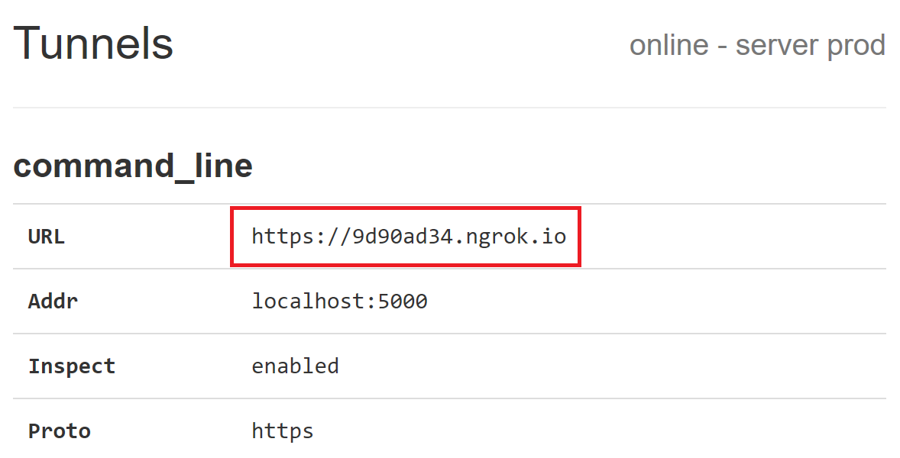

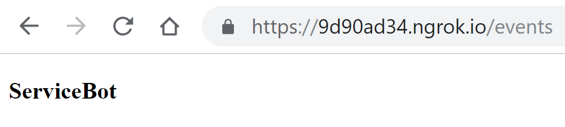Now open new tab in Chrome and open ngrok tunnel URL and you should see ServiceBot web page:

Step 3 Create bot functions in bot.py file

**def** process_message(json_data):  
 *# Create a Webhook object from the JSON data* webhook_obj = Webhook(json_data)  
 *# Get the room details* room = api.rooms.get(webhook_obj.data.roomId)  
 *# Get the message details* message = api.messages.get(webhook_obj.data.id)  
 *# Get the sender's details* person = api.people.get(message.personId)

Above we are extracting from json request 3 important elements of WebEx Teams cloud to be able to identify sender, room and get the message itself: person, room and message.

As a best practice all interactions with external entities should be logged as much as possible for easier troubleshooting.

logger.info(**"NEW MESSAGE IN ROOM '{}'"**.format(room.title))  
logger.info(**"FROM '{}'"**.format(person.displayName))  
logger.info(**"MESSAGE '{}'"**.format(message.text))

This is very important loop prevention control step. If you respond to all messages here bot will respond to its own messages that it sent and by that create a loop. Here we are filtering messages that were originated bot.

me = api.people.me()

**if** message.personId == me.id:  
 *# Message was sent by me (bot); do not respond.* **return 'OK'**

If message was sent by another user we know it should be one of the commands that is supported by the bot. As part of decomposition and isolation design we are building abstract command processing function **process_command**. For that we proceed with following steps:

* create dict from important identity parameters
* pass this dict to generic message function
* function returns list of replies that needs to be sent back to user

**else**:  
 *# Message was sent by someone else; parse message and respond.* params = dict()  
 params[**'person'**] = person  
 params[**'room'**] = room  
 params[**'message'**] = message  
 results = process_command(params)  
 **for** result **in** results:  
 *# Post the response to the room where the request was received* api.messages.create(room.id, markdown=result)  
 **return 'OK'**

The most interesting function is **process_command** as it abstracts bot layer from business logic.

**def** process_command(params):  
 command = params[**'message'**].text.lower().split()[0]  
 **if** command[0] == **'/' and f'cmd_{**command[1:]**}' in** globals():  
 **return** globals()[**f'cmd_{**command[1:]**}'**](params)  
 **elif 'cmd_default' in** globals():  
 **return** globals()[**'cmd_default'**](params)  
 **else**:  
 **return** [**'Invalid command. Please use /help for list of commands.'**]

By using **globals()** call we can get all functions defined in the current code. By naming separate command processing functions as ***cmd_<command name>*** we can enable automatic discovery and execution of commands.

There is a default command which can be defined and returned if no specific function exists to process command sent by the user. Otherwire we will get **Invalid command. Please use /help for list of commands.**

That’s it for the bot layer in the lab. On practice this layer is responsible for reliable delivery of the messages, bot redundancy operations and cloud error processing.

Step 4 Create business layer functions bi_template.py

**def** cmd_bug(params):  
 *"""**/bug <defect>** - return information for defect"""* logger.info(**"FOUND '/bug'"**)  
 bug_id = params[**'message'**].text.split()[1].strip()  
 *# Get a response* bug_headline, bug_description = get_bug_api(bug_id)  
 logger.info(**"SENDING RESPONSE FROM BUG API '{}'"**.format(bug_headline))  
 *# Post the response to the room where the request was received* results = list()  
 results.append(**'**'**+bug_id+**': '**+bug_headline+**'**'**)  
 results.append(**'- - -'**)  
 results.append(bug_description)  
 **return** results

Every function which processing specific command should compy to following rules:

* function name comprised from ***‘cmd_ ‘*** followed by the bot command name
* start with doc string defining command format and description

Usually command processing functions will business function which performs required action and return message content which needs to be delivered back to the user.

Function **cmd_help** is of specific importance because it’s used to autogenerte bot commands help and any new command which complies with above requirements will be .

**def** cmd_help(params):  
 *"""**/help** - print list of supported commands"""* results = []  
 **for** obj **in** globals():  
 **if 'cmd_' in** obj **and** obj **is not 'cmd_default'**:  
 results.append(globals()[obj].__doc__)  
 **return** results

It uses **globals()** dict which python is holding fir the current code and calls to docstring property to get the help.

Step 5 Start Service Bot and verify that you can get bug description from it Cisco Cloud.

Select script **server.py** and run it from PyCharm menu Run -> Run ‘server’

Connect to CLEUR2019 WebEx bot and test /bug commands:

/bug CSCdr72939

/bug CSCvb57414

/bug CSCuz44968

Step 6 Add another Support API handler

Check Support API documentation page and add handler for another API (EoX, Product Information or Software Suggestions)

<https://developer.cisco.com/docs/support-apis/#!automated-software-distribution>

* 1. **Create the Webex Teams bot to perform quiz for technical interviews**

**<**

**In development.**

**Content:**

* **Database connection (PSQL)**

**>**

Because you’ve solved many companies need using Webex Teams bots, your manager has decided to give you promotion. But you will need to interview new candidates for your former position. You are very busy, so don’t have enough time to talk to all of them to run preliminary checks for their technical skills. So, you decide to run the bot which will assess technical skills of candidates and decide whether you should talk in-person with them to assess further.

**<You know there is existing business template for this task, so you don’t need to write the code from scratch on your own, just start using existing Python module with your Webex Teams bot>**

*<Code to run questions one by one from the pool. Questions should be with pictures. In the end the script should show results. A student should understand this is the same test we were running in Option #1 😊>*

Option #3: Become Webex Teams bot’s developer (advanced)

Technical level of this task: **advanced**

**Option #3 Steps:**

3.1 Write sample bot.

3.2 Run internal Company’s event (Christmas Game).

3.3 Run external marketing campaign.

So, to get rid of the job, related to the technologies you are not fun of, you decided to tell the idea to your manager to write the bot to integrate it with Cisco API and give it to your support desk, so they find and fix all technical issues. Your manager is very positive about automation, but he isn’t sure you can make it. He knows you didn’t do this job before. To prove him you can do it, you decide to show him a “quick win” and write a sample bot.

**3.1 Write sample bot**

Contains: creation of the sample bot which echoes messages from a user.

[Provide detailed steps to complete the task]

* 1. **Run internal Company’s event (Secret Santa)**

<**In development. Content:**

Connection to database (PSQL)>

Everyone is very positive about your success with sample Webex Teams bot, nobody did it before you. Thanks, it’s Christmas time approaching, so, you know how to make another bot, which can help you to show you are well enough with bot’s writing. So, you come up to companie’s management with the following suggestion.

You will write a bot which will run the following Secret Santa game:

1. People willing to participate in Secret Santa game, join the Webex Teams space with bot.
2. After registration of all people has been finished (time ‘X’ has passed), the bot randomly choses pair for each participant.
3. The bot notifies participant about the pair. For this pair, the person must buy a gift and place it under a holiday tree.
4. Through the bot, participant can once ask a question from the person he has to buy a gift for (if he knows what to buy, he doesn’t need to this function, otherwise, he just clicks the button in a bot’s interface “ask”, after he clicks it, the button is just greyed out).
5. After the gift is bought, participant notifies the bot about it. If, one week before the Christmas, the bot didn’t receive confirmation from participant he bought a gift, the bot starts to notify participant once per day to buy a gift (until the confirmation is got).
6. Three days before the Christmas, the bot starts to notify a participant to place his gift under a holiday tree (once per day).
7. One day before the Christmas, bot notifies everyone to come up to a holidays tree and get gifts for them.
   1. **Run external marketing campaign**

<

**In development.Content:**

* Picture receive from the user
* Email send
* Approver web listener
* Scheduler creation

>

Your company is very proud of how the Secret Santa game were conducted. Everyone is inspired with truly innovative and modern way of running this task. So, you’ve got a query from marketing director to run external marketing campaign in a format of quest for a competition for a prize. To score points to win a prize, participants would need to answer bot’s questions about the brand of your company and post photos with themselves in a merchandise of your company (to get additional points).

**<You know there is existing business template for this task, so you don’t need to write the code from scratch on your own, just start using existing Python module with your Webex Teams bot. So, you accept this challenge>**

The bot must have the following logic:

1. People willing to participate, join the Webex Teams space with bot.
2. After registration of all people has been finished (time ‘X’ has passed), the bot randomly choses question out of a database and sends to each participant.
3. Participant answers the bot’s question and the bot either accept or decline an answer. If the bot accepts an answer – it adds points to the participant. If a participant sends photo with himself in a merchandise of your company, the bot resends this photo to marketing’s corporate email, so that this photo can be reviewed and if marketing specialist accepts it, he or she can accept this photo using a web link embedded into an email received from bot.
4. The bot sends the questions to a participant once per 3 days, it allows to post not more than 1 photo during the same period.
5. After campaign is finished, the bot generates table with results, determines the winner, and send this in a message the marketing specialist for approval. If it’s approved by marketing specialist, the bot sends congratulations to the winner.

Related Sessions at Ciscolive

Extending the Collaboration Eco-System using Webex Teams APIs for Non-Developers - BRKCOL-2175

Cognitive Collaboration – AI and Machine Learning Assisted Collaboration - BRKCOL-1460

Summary

<Summary about what has been done>

1. List of Acronyms

|  |  |
| --- | --- |
| **Acronym** | **Description** |
| SMTP | Simple Mail Transfer Protocol |
| IDE | Integrated Development Environment |
| EoX | End of support |
| RDP | Remote Desktop |
|  |  |

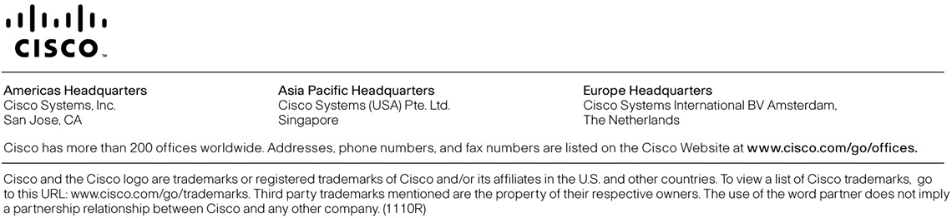

1. Check lab’s ticket to get a hash for your rack
2. Use credentials from your lab ticket or from lab proctor
3. Python 3.7.2 release.
4. Use credentials from your lab ticket or from lab proctor
5. Check lab’s ticket to get a hash for your rack
6. In the current task only HTTP GET requests would be handled by Flask
7. In the current task only HTTP GET requests would be handled by Flask